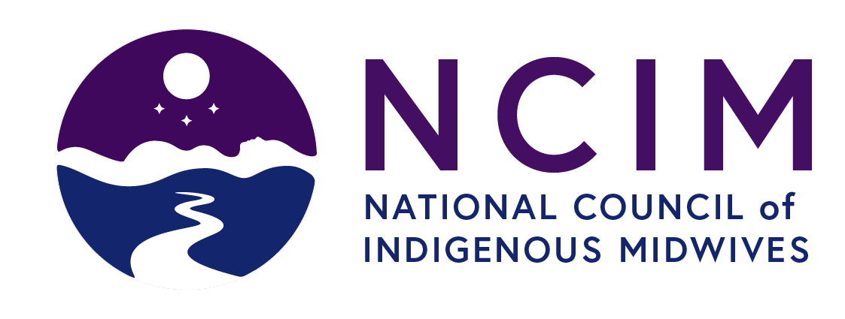
Please complete this form digitally each day and email it to admin@indigenousmidwifery.ca by the halfway point of the program. This way all the watch party participants can be included in the door prizes and receive our post-forum feedback survey. Thank you!

EVENT | Activity | Location | Organization/Host Name
2024 National Online Forum | Watch Party

no | Date | Full NAme | Email

